Machine learning Lab Observation
ITA0614
Experiment 6
Write a program to implement Naïve Bayes algorithm in python and to display the results using confusion matrix and accuracy.
Name : Sakthi K S
Reg.No : 192412247
Problem 1: Email Spam Detection

Aim
To implement the Naïve Bayes algorithm in Python to classify emails as Spam or Ham using link count, sender type and presence of spam keywords, and to display the results using a confusion matrix and accuracy.
Algorithm
1. Collect the training data set containing the features and the class labels.
2. Calculate the prior probability P(Class) for every class from the training data.
3. Calculate the likelihood P(Feature value | Class) for every feature value using Laplace smoothing.
4. For a test sample, multiply the prior and the likelihoods of all features for each class (Bayes theorem with the independence assumption).
5. Select the class with the highest posterior probability as the predicted class.
6. Repeat the prediction for all test samples and build the confusion matrix from actual and predicted classes.
7. Calculate the accuracy as (correct predictions / total predictions) and display the results.
8. Test the classifier with a new sample and display the predicted class.
Program:
# Naive Bayes Classifier with Confusion Matrix and Accuracy
import numpy as np

# Training data: (feature values..., class label)
train = [
('Few', 'Known', 'No', 'Ham'),
('Few', 'Known', 'Yes', 'Ham'),
('Many', 'Unknown', 'Yes', 'Spam'),
('Many', 'Unknown', 'No', 'Spam'),
('Few', 'Unknown', 'Yes', 'Spam'),
('Many', 'Known', 'No', 'Ham'),
('Few', 'Unknown', 'No', 'Ham'),
('Many', 'Known', 'Yes', 'Spam'),
('Many', 'Unknown', 'Yes', 'Spam'),
('Few', 'Known', 'No', 'Ham'),
('Few', 'Unknown', 'Yes', 'Spam'),
('Many', 'Known', 'No', 'Ham')
]
# Testing data
test = [
('Few', 'Known', 'No', 'Ham'),
('Many', 'Unknown', 'Yes', 'Spam'),
('Few', 'Unknown', 'Yes', 'Spam'),
('Many', 'Known', 'Yes', 'Spam'),
('Few', 'Unknown', 'No', 'Ham'),
('Many', 'Known', 'No', 'Ham')
]
classes = ['Spam', 'Ham']
new_sample = ('Many', 'Unknown', 'No')

# Separate features and labels
X_train = [r[:-1] for r in train]
y_train = [r[-1] for r in train]
X_test = [r[:-1] for r in test]
y_test = [r[-1] for r in test]

# Step 1: Prior probabilities P(class)
priors = {c: y_train.count(c) / len(y_train) for c in classes}

# Step 2: Likelihoods P(feature value | class) with Laplace smoothing
n_features = len(X_train[0])
values = [sorted(set(x[i] for x in X_train)) for i in range(n_features)]
likelihood = {}
for c in classes:
rows = [x for x, y in zip(X_train, y_train) if y == c]
for i in range(n_features):
for v in values[i]:
count = sum(1 for r in rows if r[i] == v)
likelihood[(c, i, v)] = (count + 1) / (len(rows) + len(values[i]))

# Step 3: Predict using the Bayes rule (log probabilities)
def predict(x):
scores = {}
for c in classes:
s = np.log(priors[c])
for i, v in enumerate(x):
s += np.log(likelihood[(c, i, v)])
scores[c] = s
return max(scores, key=scores.get)

y_pred = [predict(x) for x in X_test]

# Step 4: Confusion matrix (rows = actual, columns = predicted)
index = {c: k for k, c in enumerate(classes)}
cm = np.zeros((len(classes), len(classes)), dtype=int)
for a, p in zip(y_test, y_pred):
cm[index[a]][index[p]] += 1

# Step 5: Accuracy
accuracy = np.trace(cm) / np.sum(cm)

print("Actual :", y_test)
print("Predicted :", y_pred)
print("Confusion Matrix (rows = Actual, columns = Predicted):")
print("Classes :", classes)
print(cm)
print("Accuracy : {:.2f}%".format(accuracy * 100))
print("New sample:", new_sample)
print("Prediction:", predict(new_sample))

Input
Training data set:
Links | Sender | Keywords | Class
Few | Known | No | Ham
Few | Known | Yes | Ham
Many | Unknown | Yes | Spam
Many | Unknown | No | Spam
Few | Unknown | Yes | Spam
Many | Known | No | Ham
Few | Unknown | No | Ham
Many | Known | Yes | Spam
Many | Unknown | Yes | Spam
Few | Known | No | Ham
Few | Unknown | Yes | Spam
Many | Known | No | Ham

Testing data set:
Links | Sender | Keywords | Class
Few | Known | No | Ham
Many | Unknown | Yes | Spam
Few | Unknown | Yes | Spam
Many | Known | Yes | Spam
Few | Unknown | No | Ham
Many | Known | No | Ham

New sample: ('Many', 'Unknown', 'No')
Output
Actual : ['Ham', 'Spam', 'Spam', 'Spam', 'Ham', 'Ham']
Predicted : ['Ham', 'Spam', 'Spam', 'Spam', 'Ham', 'Ham']
Confusion Matrix (rows = Actual, columns = Predicted):
Classes : ['Spam', 'Ham']
[[3 0]
[0 3]]
Accuracy : 100.00%
New sample: ('Many', 'Unknown', 'No')
Prediction: Spam
Result
The Naïve Bayes classifier was successfully implemented in Python. The confusion matrix and accuracy (100.00%) were displayed for the test data, and the new sample ('Many', 'Unknown', 'No') was classified as Class = Spam.
Problem 2: Student Result Prediction
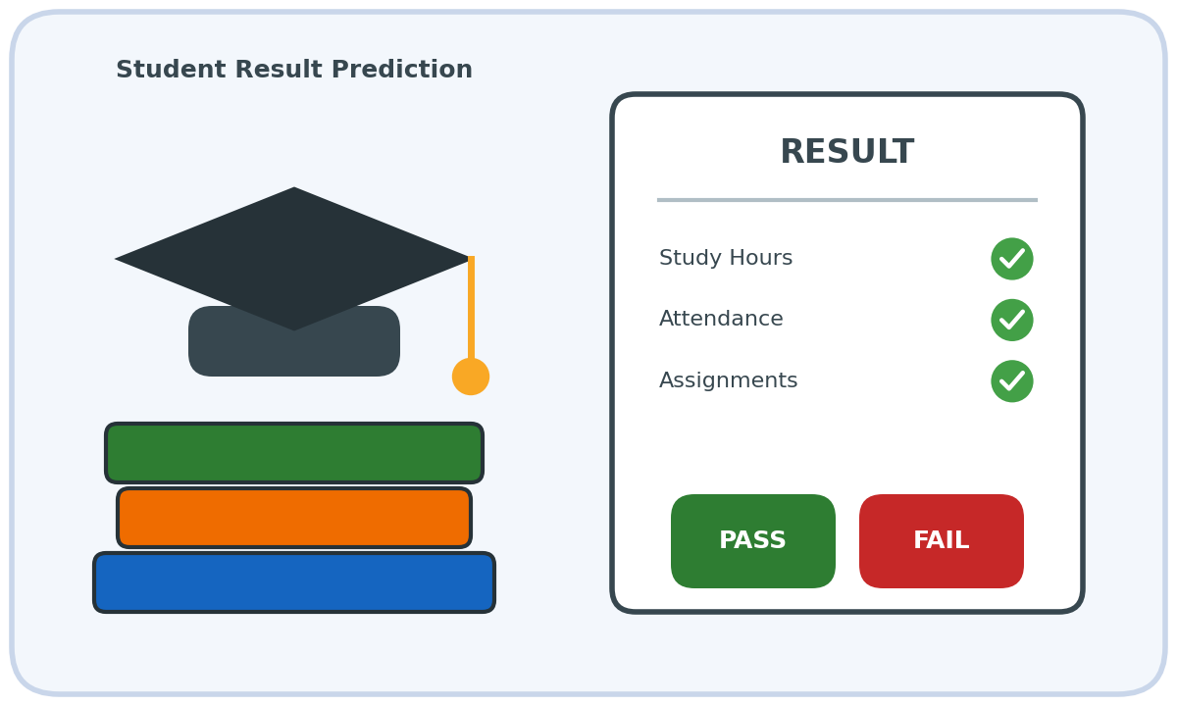
Aim
To build a Naïve Bayes classifier in Python to predict whether a student will Pass or Fail from study hours, attendance and assignment submission, and to evaluate it using a confusion matrix and accuracy.
Algorithm
1. Collect the training data set containing the features and the class labels.
2. Calculate the prior probability P(Class) for every class from the training data.
3. Calculate the likelihood P(Feature value | Class) for every feature value using Laplace smoothing.
4. For a test sample, multiply the prior and the likelihoods of all features for each class (Bayes theorem with the independence assumption).
5. Select the class with the highest posterior probability as the predicted class.
6. Repeat the prediction for all test samples and build the confusion matrix from actual and predicted classes.
7. Calculate the accuracy as (correct predictions / total predictions) and display the results.
8. Test the classifier with a new sample and display the predicted class.
Program:
# Naive Bayes Classifier with Confusion Matrix and Accuracy
import numpy as np

# Training data: (feature values..., class label)
train = [
('High', 'High', 'Done', 'Pass'),
('High', 'Low', 'Done', 'Pass'),
('Low', 'High', 'Done', 'Pass'),
('Low', 'Low', 'Pending', 'Fail'),
('Low', 'Low', 'Done', 'Fail'),
('High', 'High', 'Pending', 'Pass'),
('Low', 'High', 'Pending', 'Fail'),
('High', 'Low', 'Pending', 'Fail'),
('Low', 'Low', 'Pending', 'Fail'),
('High', 'High', 'Done', 'Pass'),
('Low', 'High', 'Done', 'Pass'),
('High', 'Low', 'Pending', 'Fail')
]
# Testing data
test = [
('High', 'High', 'Done', 'Pass'),
('Low', 'Low', 'Pending', 'Fail'),
('High', 'Low', 'Done', 'Pass'),
('Low', 'High', 'Pending', 'Fail'),
('Low', 'Low', 'Done', 'Fail'),
('High', 'High', 'Pending', 'Pass')
]
classes = ['Pass', 'Fail']
new_sample = ('High', 'Low', 'Pending')

# Separate features and labels
X_train = [r[:-1] for r in train]
y_train = [r[-1] for r in train]
X_test = [r[:-1] for r in test]
y_test = [r[-1] for r in test]

# Step 1: Prior probabilities P(class)
priors = {c: y_train.count(c) / len(y_train) for c in classes}

# Step 2: Likelihoods P(feature value | class) with Laplace smoothing
n_features = len(X_train[0])
values = [sorted(set(x[i] for x in X_train)) for i in range(n_features)]
likelihood = {}
for c in classes:
rows = [x for x, y in zip(X_train, y_train) if y == c]
for i in range(n_features):
for v in values[i]:
count = sum(1 for r in rows if r[i] == v)
likelihood[(c, i, v)] = (count + 1) / (len(rows) + len(values[i]))

# Step 3: Predict using the Bayes rule (log probabilities)
def predict(x):
scores = {}
for c in classes:
s = np.log(priors[c])
for i, v in enumerate(x):
s += np.log(likelihood[(c, i, v)])
scores[c] = s
return max(scores, key=scores.get)

y_pred = [predict(x) for x in X_test]

# Step 4: Confusion matrix (rows = actual, columns = predicted)
index = {c: k for k, c in enumerate(classes)}
cm = np.zeros((len(classes), len(classes)), dtype=int)
for a, p in zip(y_test, y_pred):
cm[index[a]][index[p]] += 1

# Step 5: Accuracy
accuracy = np.trace(cm) / np.sum(cm)

print("Actual :", y_test)
print("Predicted :", y_pred)
print("Confusion Matrix (rows = Actual, columns = Predicted):")
print("Classes :", classes)
print(cm)
print("Accuracy : {:.2f}%".format(accuracy * 100))
print("New sample:", new_sample)
print("Prediction:", predict(new_sample))

Input
Training data set:
StudyHours | Attendance | Assignments | Result
High | High | Done | Pass
High | Low | Done | Pass
Low | High | Done | Pass
Low | Low | Pending | Fail
Low | Low | Done | Fail
High | High | Pending | Pass
Low | High | Pending | Fail
High | Low | Pending | Fail
Low | Low | Pending | Fail
High | High | Done | Pass
Low | High | Done | Pass
High | Low | Pending | Fail

Testing data set:
StudyHours | Attendance | Assignments | Result
High | High | Done | Pass
Low | Low | Pending | Fail
High | Low | Done | Pass
Low | High | Pending | Fail
Low | Low | Done | Fail
High | High | Pending | Pass

New sample: ('High', 'Low', 'Pending')
Output
Actual : ['Pass', 'Fail', 'Pass', 'Fail', 'Fail', 'Pass']
Predicted : ['Pass', 'Fail', 'Pass', 'Fail', 'Fail', 'Pass']
Confusion Matrix (rows = Actual, columns = Predicted):
Classes : ['Pass', 'Fail']
[[3 0]
[0 3]]
Accuracy : 100.00%
New sample: ('High', 'Low', 'Pending')
Prediction: Fail
Result
The Naïve Bayes classifier was successfully implemented in Python. The confusion matrix and accuracy (100.00%) were displayed for the test data, and the new sample ('High', 'Low', 'Pending') was classified as Result = Fail.
Problem 3: Rain Prediction
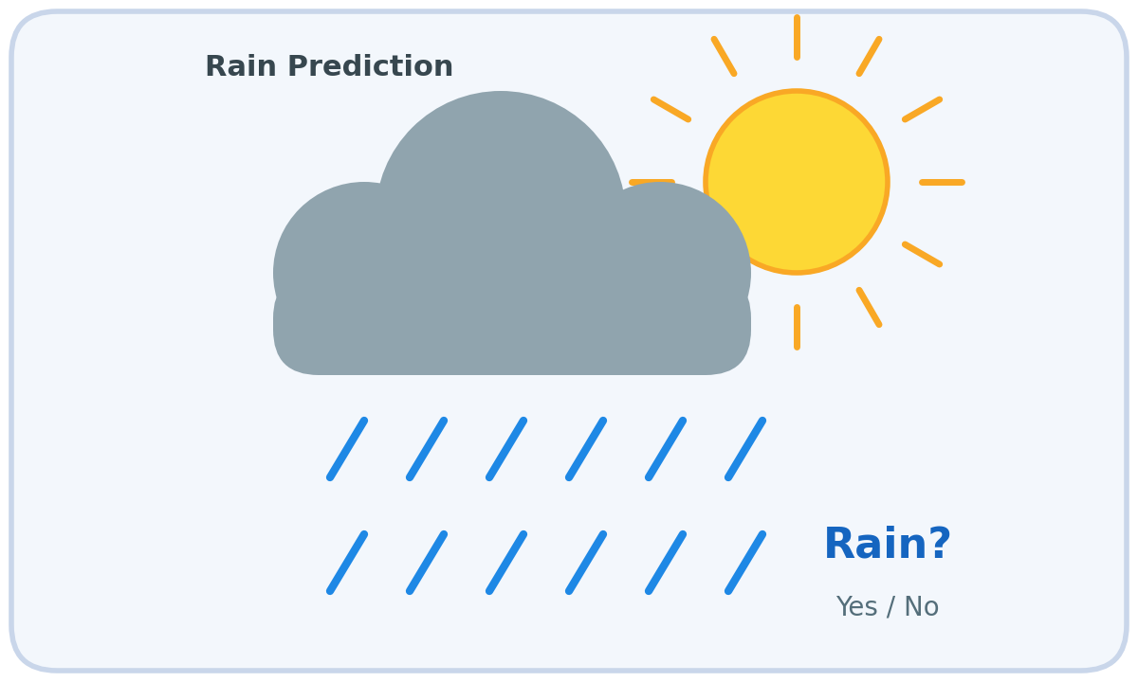
Aim
To implement the Naïve Bayes algorithm in Python for predicting whether it will rain from humidity, cloud cover and wind speed, and to display the performance using a confusion matrix and accuracy.
Algorithm
1. Collect the training data set containing the features and the class labels.
2. Calculate the prior probability P(Class) for every class from the training data.
3. Calculate the likelihood P(Feature value | Class) for every feature value using Laplace smoothing.
4. For a test sample, multiply the prior and the likelihoods of all features for each class (Bayes theorem with the independence assumption).
5. Select the class with the highest posterior probability as the predicted class.
6. Repeat the prediction for all test samples and build the confusion matrix from actual and predicted classes.
7. Calculate the accuracy as (correct predictions / total predictions) and display the results.
8. Test the classifier with a new sample and display the predicted class.
Program:
# Naive Bayes Classifier with Confusion Matrix and Accuracy
import numpy as np

# Training data: (feature values..., class label)
train = [
('High', 'Cloudy', 'Weak', 'Yes'),
('High', 'Cloudy', 'Strong', 'Yes'),
('High', 'Clear', 'Weak', 'No'),
('Normal', 'Cloudy', 'Weak', 'No'),
('Normal', 'Clear', 'Strong', 'No'),
('High', 'Cloudy', 'Weak', 'Yes'),
('Normal', 'Cloudy', 'Strong', 'Yes'),
('Normal', 'Clear', 'Weak', 'No'),
('High', 'Clear', 'Strong', 'No'),
('High', 'Cloudy', 'Strong', 'Yes'),
('Normal', 'Clear', 'Weak', 'No'),
('Normal', 'Cloudy', 'Weak', 'No')
]
# Testing data
test = [
('High', 'Cloudy', 'Weak', 'Yes'),
('Normal', 'Clear', 'Strong', 'No'),
('High', 'Clear', 'Weak', 'No'),
('Normal', 'Cloudy', 'Strong', 'Yes'),
('High', 'Cloudy', 'Strong', 'Yes'),
('Normal', 'Cloudy', 'Weak', 'No')
]
classes = ['Yes', 'No']
new_sample = ('High', 'Cloudy', 'Weak')

# Separate features and labels
X_train = [r[:-1] for r in train]
y_train = [r[-1] for r in train]
X_test = [r[:-1] for r in test]
y_test = [r[-1] for r in test]

# Step 1: Prior probabilities P(class)
priors = {c: y_train.count(c) / len(y_train) for c in classes}

# Step 2: Likelihoods P(feature value | class) with Laplace smoothing
n_features = len(X_train[0])
values = [sorted(set(x[i] for x in X_train)) for i in range(n_features)]
likelihood = {}
for c in classes:
rows = [x for x, y in zip(X_train, y_train) if y == c]
for i in range(n_features):
for v in values[i]:
count = sum(1 for r in rows if r[i] == v)
likelihood[(c, i, v)] = (count + 1) / (len(rows) + len(values[i]))

# Step 3: Predict using the Bayes rule (log probabilities)
def predict(x):
scores = {}
for c in classes:
s = np.log(priors[c])
for i, v in enumerate(x):
s += np.log(likelihood[(c, i, v)])
scores[c] = s
return max(scores, key=scores.get)

y_pred = [predict(x) for x in X_test]

# Step 4: Confusion matrix (rows = actual, columns = predicted)
index = {c: k for k, c in enumerate(classes)}
cm = np.zeros((len(classes), len(classes)), dtype=int)
for a, p in zip(y_test, y_pred):
cm[index[a]][index[p]] += 1

# Step 5: Accuracy
accuracy = np.trace(cm) / np.sum(cm)

print("Actual :", y_test)
print("Predicted :", y_pred)
print("Confusion Matrix (rows = Actual, columns = Predicted):")
print("Classes :", classes)
print(cm)
print("Accuracy : {:.2f}%".format(accuracy * 100))
print("New sample:", new_sample)
print("Prediction:", predict(new_sample))

Input
Training data set:
Humidity | Clouds | Wind | Rain
High | Cloudy | Weak | Yes
High | Cloudy | Strong | Yes
High | Clear | Weak | No
Normal | Cloudy | Weak | No
Normal | Clear | Strong | No
High | Cloudy | Weak | Yes
Normal | Cloudy | Strong | Yes
Normal | Clear | Weak | No
High | Clear | Strong | No
High | Cloudy | Strong | Yes
Normal | Clear | Weak | No
Normal | Cloudy | Weak | No

Testing data set:
Humidity | Clouds | Wind | Rain
High | Cloudy | Weak | Yes
Normal | Clear | Strong | No
High | Clear | Weak | No
Normal | Cloudy | Strong | Yes
High | Cloudy | Strong | Yes
Normal | Cloudy | Weak | No

New sample: ('High', 'Cloudy', 'Weak')
Output
Actual : ['Yes', 'No', 'No', 'Yes', 'Yes', 'No']
Predicted : ['Yes', 'No', 'No', 'Yes', 'Yes', 'No']
Confusion Matrix (rows = Actual, columns = Predicted):
Classes : ['Yes', 'No']
[[3 0]
[0 3]]
Accuracy : 100.00%
New sample: ('High', 'Cloudy', 'Weak')
Prediction: Yes
Result
The Naïve Bayes classifier was successfully implemented in Python. The confusion matrix and accuracy (100.00%) were displayed for the test data, and the new sample ('High', 'Cloudy', 'Weak') was classified as Rain = Yes.
Problem 4: Loan Approval Prediction
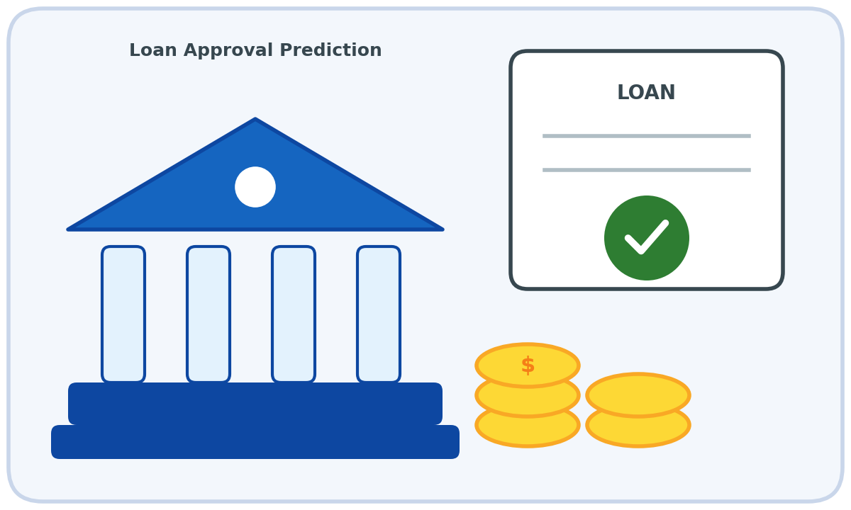
Aim
To develop a Naïve Bayes classifier in Python that predicts loan approval from income level, credit score and employment type, and to analyse the results using a confusion matrix and accuracy.
Algorithm
1. Collect the training data set containing the features and the class labels.
2. Calculate the prior probability P(Class) for every class from the training data.
3. Calculate the likelihood P(Feature value | Class) for every feature value using Laplace smoothing.
4. For a test sample, multiply the prior and the likelihoods of all features for each class (Bayes theorem with the independence assumption).
5. Select the class with the highest posterior probability as the predicted class.
6. Repeat the prediction for all test samples and build the confusion matrix from actual and predicted classes.
7. Calculate the accuracy as (correct predictions / total predictions) and display the results.
8. Test the classifier with a new sample and display the predicted class.
Program:
# Naive Bayes Classifier with Confusion Matrix and Accuracy
import numpy as np

# Training data: (feature values..., class label)
train = [
('High', 'Good', 'Salaried', 'Approved'),
('High', 'Good', 'SelfEmployed', 'Approved'),
('Medium', 'Good', 'Salaried', 'Approved'),
('Low', 'Poor', 'SelfEmployed', 'Rejected'),
('Low', 'Good', 'Salaried', 'Approved'),
('Medium', 'Poor', 'Salaried', 'Rejected'),
('High', 'Poor', 'SelfEmployed', 'Rejected'),
('Low', 'Poor', 'Salaried', 'Rejected'),
('Medium', 'Good', 'SelfEmployed', 'Approved'),
('Low', 'Poor', 'SelfEmployed', 'Rejected'),
('High', 'Good', 'Salaried', 'Approved'),
('Medium', 'Poor', 'SelfEmployed', 'Rejected')
]
# Testing data
test = [
('High', 'Good', 'Salaried', 'Approved'),
('Low', 'Poor', 'Salaried', 'Rejected'),
('Medium', 'Good', 'SelfEmployed', 'Approved'),
('High', 'Poor', 'Salaried', 'Rejected'),
('Low', 'Good', 'SelfEmployed', 'Approved'),
('Medium', 'Poor', 'SelfEmployed', 'Rejected')
]
classes = ['Approved', 'Rejected']
new_sample = ('Medium', 'Good', 'Salaried')

# Separate features and labels
X_train = [r[:-1] for r in train]
y_train = [r[-1] for r in train]
X_test = [r[:-1] for r in test]
y_test = [r[-1] for r in test]

# Step 1: Prior probabilities P(class)
priors = {c: y_train.count(c) / len(y_train) for c in classes}

# Step 2: Likelihoods P(feature value | class) with Laplace smoothing
n_features = len(X_train[0])
values = [sorted(set(x[i] for x in X_train)) for i in range(n_features)]
likelihood = {}
for c in classes:
rows = [x for x, y in zip(X_train, y_train) if y == c]
for i in range(n_features):
for v in values[i]:
count = sum(1 for r in rows if r[i] == v)
likelihood[(c, i, v)] = (count + 1) / (len(rows) + len(values[i]))

# Step 3: Predict using the Bayes rule (log probabilities)
def predict(x):
scores = {}
for c in classes:
s = np.log(priors[c])
for i, v in enumerate(x):
s += np.log(likelihood[(c, i, v)])
scores[c] = s
return max(scores, key=scores.get)

y_pred = [predict(x) for x in X_test]

# Step 4: Confusion matrix (rows = actual, columns = predicted)
index = {c: k for k, c in enumerate(classes)}
cm = np.zeros((len(classes), len(classes)), dtype=int)
for a, p in zip(y_test, y_pred):
cm[index[a]][index[p]] += 1

# Step 5: Accuracy
accuracy = np.trace(cm) / np.sum(cm)

print("Actual :", y_test)
print("Predicted :", y_pred)
print("Confusion Matrix (rows = Actual, columns = Predicted):")
print("Classes :", classes)
print(cm)
print("Accuracy : {:.2f}%".format(accuracy * 100))
print("New sample:", new_sample)
print("Prediction:", predict(new_sample))

Input
Training data set:
Income | CreditScore | Employment | Loan
High | Good | Salaried | Approved
High | Good | SelfEmployed | Approved
Medium | Good | Salaried | Approved
Low | Poor | SelfEmployed | Rejected
Low | Good | Salaried | Approved
Medium | Poor | Salaried | Rejected
High | Poor | SelfEmployed | Rejected
Low | Poor | Salaried | Rejected
Medium | Good | SelfEmployed | Approved
Low | Poor | SelfEmployed | Rejected
High | Good | Salaried | Approved
Medium | Poor | SelfEmployed | Rejected

Testing data set:
Income | CreditScore | Employment | Loan
High | Good | Salaried | Approved
Low | Poor | Salaried | Rejected
Medium | Good | SelfEmployed | Approved
High | Poor | Salaried | Rejected
Low | Good | SelfEmployed | Approved
Medium | Poor | SelfEmployed | Rejected

New sample: ('Medium', 'Good', 'Salaried')
Output
Actual : ['Approved', 'Rejected', 'Approved', 'Rejected', 'Approved', 'Rejected']
Predicted : ['Approved', 'Rejected', 'Approved', 'Rejected', 'Approved', 'Rejected']
Confusion Matrix (rows = Actual, columns = Predicted):
Classes : ['Approved', 'Rejected']
[[3 0]
[0 3]]
Accuracy : 100.00%
New sample: ('Medium', 'Good', 'Salaried')
Prediction: Approved
Result
The Naïve Bayes classifier was successfully implemented in Python. The confusion matrix and accuracy (100.00%) were displayed for the test data, and the new sample ('Medium', 'Good', 'Salaried') was classified as Loan = Approved.
Problem 5: Flu Diagnosis

Aim
To implement the Naïve Bayes algorithm in Python for diagnosing flu from fever, cough and body ache symptoms, and to display the results using a confusion matrix and accuracy.
Algorithm
1. Collect the training data set containing the features and the class labels.
2. Calculate the prior probability P(Class) for every class from the training data.
3. Calculate the likelihood P(Feature value | Class) for every feature value using Laplace smoothing.
4. For a test sample, multiply the prior and the likelihoods of all features for each class (Bayes theorem with the independence assumption).
5. Select the class with the highest posterior probability as the predicted class.
6. Repeat the prediction for all test samples and build the confusion matrix from actual and predicted classes.
7. Calculate the accuracy as (correct predictions / total predictions) and display the results.
8. Test the classifier with a new sample and display the predicted class.
Program:
# Naive Bayes Classifier with Confusion Matrix and Accuracy
import numpy as np

# Training data: (feature values..., class label)
train = [
('High', 'Yes', 'Yes', 'Yes'),
('High', 'Yes', 'No', 'Yes'),
('High', 'No', 'Yes', 'Yes'),
('Normal', 'No', 'No', 'No'),
('Normal', 'Yes', 'No', 'No'),
('Normal', 'No', 'Yes', 'No'),
('High', 'No', 'No', 'No'),
('Normal', 'Yes', 'Yes', 'Yes'),
('High', 'Yes', 'Yes', 'Yes'),
('Normal', 'No', 'No', 'No'),
('Normal', 'Yes', 'No', 'No'),
('High', 'No', 'Yes', 'Yes')
]
# Testing data
test = [
('High', 'Yes', 'Yes', 'Yes'),
('Normal', 'No', 'No', 'No'),
('High', 'No', 'No', 'No'),
('Normal', 'Yes', 'Yes', 'Yes'),
('Normal', 'Yes', 'No', 'No'),
('High', 'Yes', 'No', 'Yes')
]
classes = ['Yes', 'No']
new_sample = ('High', 'No', 'Yes')

# Separate features and labels
X_train = [r[:-1] for r in train]
y_train = [r[-1] for r in train]
X_test = [r[:-1] for r in test]
y_test = [r[-1] for r in test]

# Step 1: Prior probabilities P(class)
priors = {c: y_train.count(c) / len(y_train) for c in classes}

# Step 2: Likelihoods P(feature value | class) with Laplace smoothing
n_features = len(X_train[0])
values = [sorted(set(x[i] for x in X_train)) for i in range(n_features)]
likelihood = {}
for c in classes:
rows = [x for x, y in zip(X_train, y_train) if y == c]
for i in range(n_features):
for v in values[i]:
count = sum(1 for r in rows if r[i] == v)
likelihood[(c, i, v)] = (count + 1) / (len(rows) + len(values[i]))

# Step 3: Predict using the Bayes rule (log probabilities)
def predict(x):
scores = {}
for c in classes:
s = np.log(priors[c])
for i, v in enumerate(x):
s += np.log(likelihood[(c, i, v)])
scores[c] = s
return max(scores, key=scores.get)

y_pred = [predict(x) for x in X_test]

# Step 4: Confusion matrix (rows = actual, columns = predicted)
index = {c: k for k, c in enumerate(classes)}
cm = np.zeros((len(classes), len(classes)), dtype=int)
for a, p in zip(y_test, y_pred):
cm[index[a]][index[p]] += 1

# Step 5: Accuracy
accuracy = np.trace(cm) / np.sum(cm)

print("Actual :", y_test)
print("Predicted :", y_pred)
print("Confusion Matrix (rows = Actual, columns = Predicted):")
print("Classes :", classes)
print(cm)
print("Accuracy : {:.2f}%".format(accuracy * 100))
print("New sample:", new_sample)
print("Prediction:", predict(new_sample))

Input
Training data set:
Fever | Cough | BodyAche | Flu
High | Yes | Yes | Yes
High | Yes | No | Yes
High | No | Yes | Yes
Normal | No | No | No
Normal | Yes | No | No
Normal | No | Yes | No
High | No | No | No
Normal | Yes | Yes | Yes
High | Yes | Yes | Yes
Normal | No | No | No
Normal | Yes | No | No
High | No | Yes | Yes

Testing data set:
Fever | Cough | BodyAche | Flu
High | Yes | Yes | Yes
Normal | No | No | No
High | No | No | No
Normal | Yes | Yes | Yes
Normal | Yes | No | No
High | Yes | No | Yes

New sample: ('High', 'No', 'Yes')
Output
Actual : ['Yes', 'No', 'No', 'Yes', 'No', 'Yes']
Predicted : ['Yes', 'No', 'No', 'Yes', 'No', 'Yes']
Confusion Matrix (rows = Actual, columns = Predicted):
Classes : ['Yes', 'No']
[[3 0]
[0 3]]
Accuracy : 100.00%
New sample: ('High', 'No', 'Yes')
Prediction: Yes
Result
The Naïve Bayes classifier was successfully implemented in Python. The confusion matrix and accuracy (100.00%) were displayed for the test data, and the new sample ('High', 'No', 'Yes') was classified as Flu = Yes.

